GULISTAN & TURGUT OZAL EDUCATIONAL INSTITUTIONS
INFORMATICS LESSON PLAN
DATE :
DURATION : | 40 minutes
GRADE LEVEL: | 10th Class
SUBJECT : | Editing a Worksheet, Mouse Operations
OBJECTIVES : | To learn the essential Editing Techniques
LESSON PLAN
Key words:
Materials used: | Microsoft Excel 2003 Book, Computer
Warm-up questions:
Introduction and explanation of the lesson;
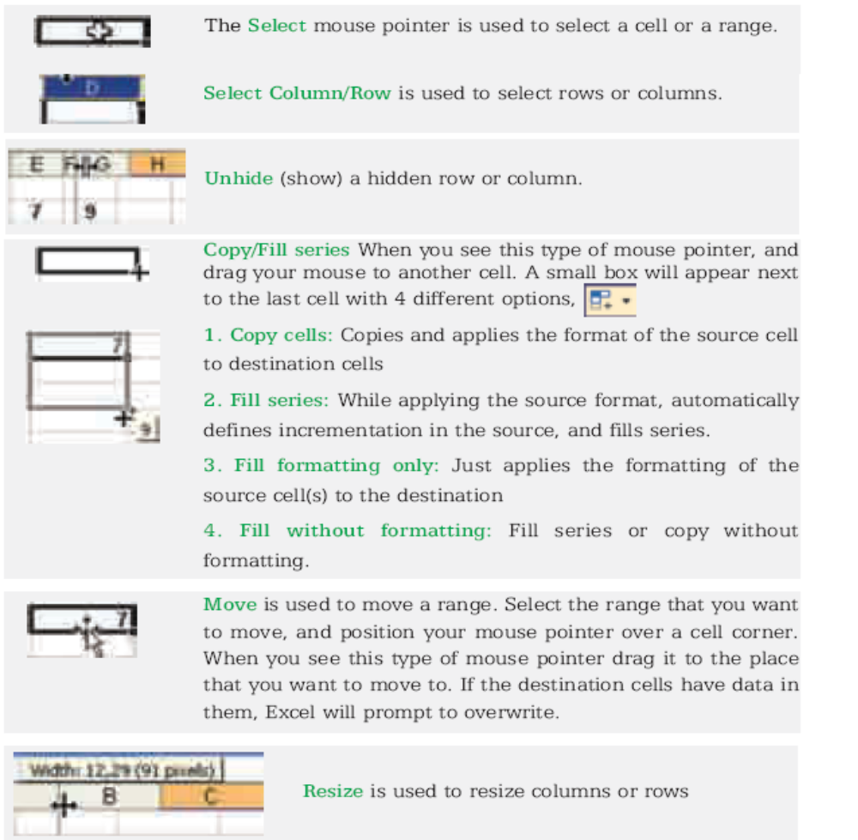

CONCLUSION:

HOMEWORK:

Teacher Director

